[1]

# Discussion of Printer Control Software

Table 2. Comparison chart of three open-source printer control software for DLP printers and details of Project PAM’s printer control software.

|  |  |  |  |  |
| --- | --- | --- | --- | --- |
|  | B9 Creator | MiiCraft | Creation Workshop | Project PAM |
| Language | C++ [4] | Python [11] | C# [14] | C++ |
| Cross-platform | ✓ [7] | ✗ [10] | ✓ [13] | ✓ |
| Slicing Software | Custom [9] | Skeinforge [11] | Slic3r [14] | Slic3r |
| G-Code Support | ✗ [9] | ✓ [11] | ✓ [14] | ✓ |
| CAD File Input | STL [7] | STL [10] | STL, OBJ, 3DS [13] | STL, OBJ, 3DS, STEP, AMF |
| Ablity to Add Supports | ✓ [7] | ✗ [10] | ✓ [13] | ✓ |
| Image Output | SLC [9] | SVG [12] | SVG [16] | SVG |

With the recent rise of DLP 3D printing in the hobbyist market there is a need for a more consolidated form of printer control software. Current implantations are very printer specific. There is a need for standard printer control software for all DLP 3D printers. One exception to this is the Creation Workshop by Steve Hernandez. Table 1 shows the comparison of three open-source printer control software. The only real similarity between the three is that the software is licensed under the GNU General Purpose License, which allows free distribution and modification of the software [1].

There a few requirements that Project PAM’s printer control software has to meet. Table 1 lists these requirements/features. First, in order to support any resolution projector an image output has to be used that supports any resolution. The W3C standard scalable vector graphics 1.1 support just that [2]. Because of this any solution we use must support layer image output as SVGs. The next requirement is that the software needs to support multiple file formats for the CAD files that are imported. The current standard CAD file format for 3D printing is STL files [3]. In 2011 Additive Manufacturing File Format (AMF) was released, a superset of STL, by the International Organization of Standards (ISO) and American Society for Testing and Materials (ASTM) as ISO/ASTM 52915:2013 [4]. Also, because curves can be better displayed with a PAM system, STEP files will also need to be supported [5]. The final requirement is that the slicing software must support G-Code. G-Code is used heavily in CNC machining and has been adapted by 3D printing hobbyist. G-Code is also an ISO standard, ISO 6983-1:2009 [6].

## B9 Creator Software

The B9 Creator is a crowdsourced open-source DLP printer [7] [8]. The B9 Creator’s printer control software is written in C++, using the Qt library for the user interface [9]. It supports STL CAD files as the model input [7], the standard for 3D printing [3]. *Support structure can be manually* added after the import of the STL file [7]. The slicing of each individual layer is done by a custom implementation and outputs SLC files, SLC files are CAD slice files [9]. However, because it uses a custom implementation for slicing there is no standard G-code support.

Table 1. Project PAM Printer Control Software Feature List

|  |  |
| --- | --- |
| Feature | Description |
| Layer Images as SVGs | The layers must be outputted as SVG files. |
| Multiple CAD file format support | Multiple CAD file formats must be able to be supported for imported models. |
| G-Code Support | G-Code generation must be supported by the slicing software. |
| Ability to Add Multiple CAD Models | User has the ability to add multiple CAD models to the layout to be printed. |
| Ability to View Individual Layer Images | User has the ability to view each individual layer image that will be outputted. |
| Resin Catalog | User configurable database of different resins that can be selected at time of print. |
| Projector Catalog | User configurable database of different projectors that can be selected at time of print. |
| Defaults | User has the ability to set defaults for all settings to allow quicker setup time. |
| Print Projects | Printing settings will be saved for specific prints to allow easier reprints. |

## MiiCraft Suite

The MiiCraft printer is a DLP printer that has closed-source hardware; however, it has open source printer control software [10]. The MiiCraft’s printer control software, or MiiCraft Suite as it has been dubbed, is written in Python, and uses Tkinter for the user interface [11]. Unlike the B9 Creator and the Creation Workshop the MiiCraft is not cross-platform and only supports Windows [10]. It supports STL CAD files as the model input. The software does not give the user the ability to add supports to the model before printing [10]. Skeinforge is the slicing software used by the MiiCraft [11], which supports the output of each layer as a SVG file through its Vectorwrite plugin [12].

## Creation Workshop

The Creation Workshop is an attempt to provide printer control software for any DLP printer, however it also supports FDM printers [13]. It is written in C#, using OpenTK, which is a C# wrapper for OpenGL, for the user interface [14] [15]. Unlike the B9 Creator and the MiiCraft the Creation Workshop does not only support STL CAD files for the model import, it also supports OBJ and 3DS files [13]. The software does allow supports to be added after the CAD file has been imported. The Creation Workshop uses Slic3r for the slicing software [14], which is written in Perl and supports outputting the layers as SVG files [16]. The Creation Workshop also supports G-code for DLP printers [13].

Of the three open source printer control software evaluated, the Creation Workshop printer is the most powerful. The reason for this is that it uses Slic3r as its slicing engine, which is *the most popular slicing engine* [17]. The other benefit it has over the other two is that it gives the user more freedom than any other printer control software on the market for DLP printers.

## Project PAM

After further investigation into the Creation Workshop it became aperient it was poorly implemented. The idea of Creation Workshop is great, a single piece of software to control all DLP printers; however, that great idea is lost in over complexity and a clunky user interface design. To further complicate modifying the Creation Workshop, none of the team members have experience in C#. Because of these reasons the decision has been made to modify the B9 Creator printer control software. This allows the use C++ or the ISO standard, ISO/IEC 14882:2011 [18]. Of the features listed in Table 2 the B9 Creator’s software has all but the capacity to output layer images as SVGs, the support of multiple CAD file formats, G-Code support, the projector catalog, and the ability to view individual layer images.

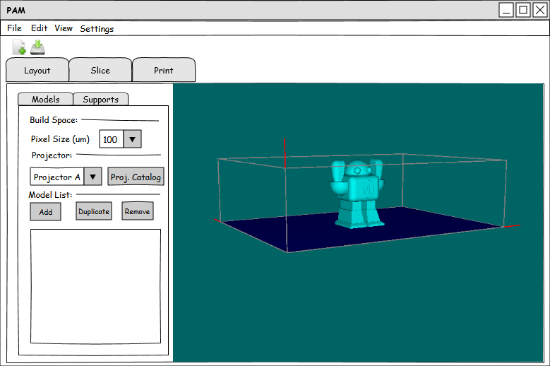

Fig. 3. Layout Page of Project PAM Printer Control Software.

These short comings can be easily alleviated by exchanging the current custom slicing software used by the B9 to Slic3r. This change will add SVG support and G-Code support. The final change that will have to be made is to take adapt the Creation Workshop’s support for multiple CAD file formats and capacity to display individual layer images. With those changes to the B9 Creator all the requirements/features should be met.

The flow diagram for Project PAM’s printer control software is shown in Figure 1. The layout software and slicing software will be executed in the printer control software. When a user first opens up Project PAM they will see Figure 2, the Startup Page. In the Startup Page the user will be able to select from a list of recent projects, browse to another project not in this list, or create a new “blank” project. The projects and all associated data will be stored in the W3C standard, Extensible Markup Language (XML) files [19]. Upon the creation of a “blank” project the settings will be set to user definable defaults.



Fig. 1. Flow Diagram of Project PAM Printer Control Software.

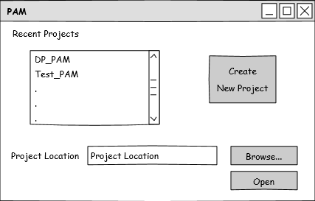

Fig. 2. Startup Page of Project PAM Printer Control Software.

The first page, after the Startup Page, is the Layout page, Figure 3. In the Layout Page the user will select a pixel size (resolution) and the projector from the projector catalog. Also, the user will be able to edit the projector catalog from this page. The biggest functionality on this page is the user has the ability to add as many models to the layout and manipulate those models within the layout edit window.

The next page is the Slice Page, Figure 4. On this page the user sets settings for Slic3r and runs it. After Slic3r is run the user can view and edit the G-Code in a separate text editor window. Also, the user can scroll through all the layer images Slic3r produced.

The final page is the Print Page, Figure 5. On this page the user can “play”, “pause”, and “stop” the print. Before the user can start the print the settings need to be set and there is a checklist that the user has to go through to verify the printer is properly working and configured. The user can also manually type G-Code to be sent to the printer. Also, the user can manually lower and raise the build table with up and down arrows. The final functionality on this page is the display of time remaining and a progress bar showing the current layer.

With these modifications to the B9 Creator software the requirements/features in Table 1 will fully be met, and Project PAM will hopefully become the first printer control software to support any PAM system, the most powerful printer control software, and the most open printer control software. This will be done by using Slic3r, *the most popular slicing engine* [17], licensing under the GNU GPL, and maximizing user freedom and control in the software.

# References

[1] Free Software Foundation, "GNU.org," 29 June 2007. [Online]. Available: https://www.gnu.org/copyleft/gpl.html. [Accessed 17 April 2014].

[2] W3C, "Scalable Vector Graphics (SVG) 1.1 (Second Edition)," 16 August 2011. [Online]. Available: http://www.w3.org/TR/SVG/. [Accessed 16 April 2014].

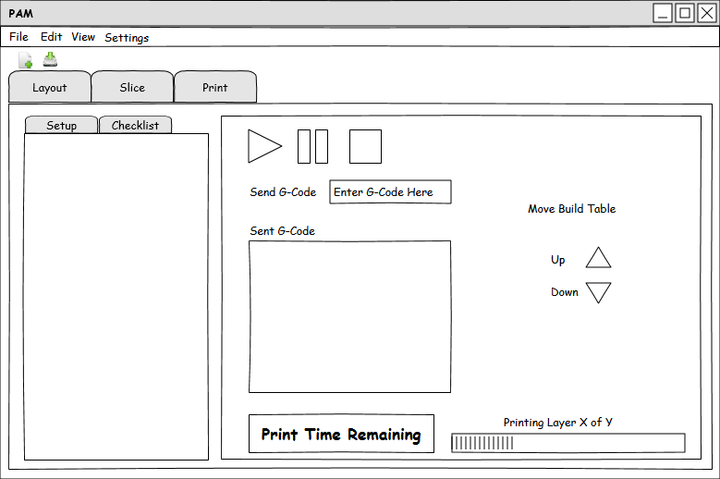

Fig. 5. Print Page of Project PAM Printer Control Software.

[3] S. Ragan, "Software for 3D Printing," Make: Ultimate Guide to 3D Printing, pp. 34-35.

[4] ISO/ASTM 52915:2013, Standard specification for additive manufacturing file format (AMF) Version 1.1.

[5] ISO 10303-21:2002, Industrial automation systems and integration -- Product data representation and exchange -- Part 21: Implementation methods: Clear text encoding of the exchange structure.

[6] ISO 6983-1:2009, Automation systems and integration -- Numerical control of machines -- Program format and definitions of address words -- Part 1: Data format for positioning, line motion and contouring control systems.

[7] E. Chu, "B9 Creator," Make: Ultimate Guide to 3D Printing, p. 93.

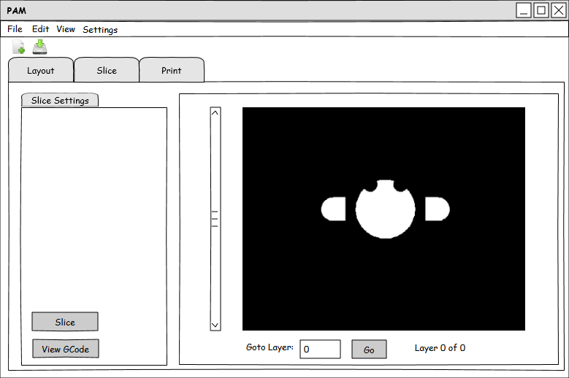

Fig. 4. Slice Page of Project PAM Printer Control Software.

[8] "B9 Creator," B9 Creations LLC, 2013. [Online]. Available: http://b9creator.com/. [Accessed 27 February 2014].

[9] B9 Creations LLC, "B9 Creator GitHub," GitHub Inc., 2014. [Online]. Available: https://github.com/B9Creations/B9Creator. [Accessed 27 February 2014].

[10] Rays Optics Inc., "MiiCraft User Guide," 2012. [Online]. Available: http://www.miicraft.com/web/assets/2012/11/MiiCraft-3D-printer-User-Guide.pdf. [Accessed 27 February 2014].

[11] MiiCraft, "MiiCraft Suite GitHub," GitHub Inc., 2014. [Online]. Available: https://github.com/miicraft/MiiCraftSuite. [Accessed 27 February 2014].

[12] Fabmetheus, "Skeinforge Vectorwrite," Demozendium, 17 July 2012. [Online]. Available: http://fabmetheus.crsndoo.com/wiki/index.php/Skeinforge_Vectorwrite. [Accessed 27 February 2014].

[13] S. Hernandez, "Creation Workshop - SLA / FDM Slicer and Controller," Makerbot Industries LLC, 8 January 2013. [Online]. Available: https://www.thingiverse.com/thing:40778. [Accessed 27 February 2014].

[14] S. Hernandez, "Creation Workshop GitHub," GitHub Inc., 2014. [Online]. Available: https://github.com/Pacmanfan/UVDLPSlicerController. [Accessed 27 February 2014].

[15] S. Apostolopoulos, "OpenTK," Stefanos A. Icons, 2013. [Online]. Available: http://www.opentk.com/. [Accessed 27 February 2014].

[16] A. Ranellucci, "Slic3r Manual," GitHub Inc., 2014. [Online]. Available: https://github.com/alexrj/Slic3r-Manual. [Accessed 27 February 2014].

[17] J. Abella, "Slicing and Control Software: Where it's going and where it's been," Make: Ultimate Guide to 3D Printing, p. 90.

[18] ISO/IEC 14882:2011, Information technology -- Programming languages -- C++.

[19] W3C, "XML 1.1 Extensible Markup Language (XML) 1.1 (Second Edition)," 16 August 2006. [Online]. Available: http://www.w3.org/TR/2006/REC-xml11-20060816/. [Accessed 16 April 2014].

1.